Name :- Shaik Mohammed Kaif
Reg no :- 192311259
Course code :- CSA1616
Course Name:- Data Warehousing and Data Mining

Experiment-4
AIM:- To implement and compare Min-Max, Z-score, and Decimal Scaling normalization techniques on the age data of 18 adults using R programming.
Code:-
age <- c(22, 25, 28, 30, 32, 35, 38, 40, 42,
45, 48, 50, 52, 55, 58, 60, 65, 70)
# Min-Max Normalization
minmax <- (age - min(age)) / (max(age) - min(age))
# Z-Score Normalization
zscore <- (age - mean(age)) / sd(age)
# Decimal Scaling Normalization
decimal <- age / 100
print(minmax)
print(zscore)
print(decimal)

Output:-

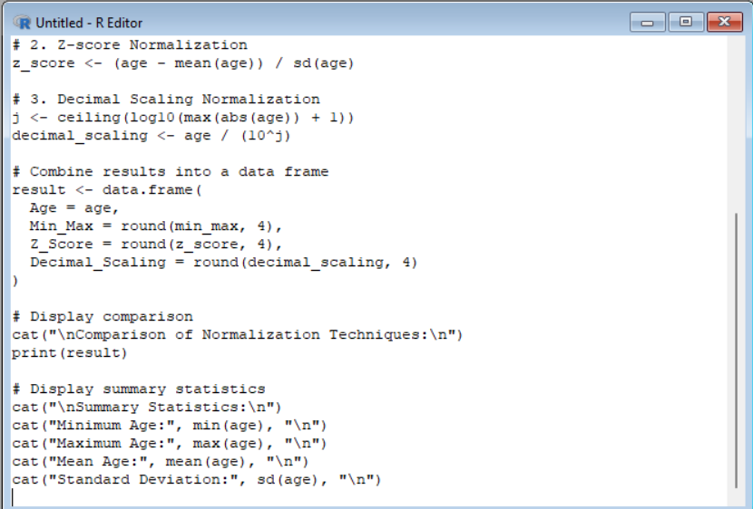

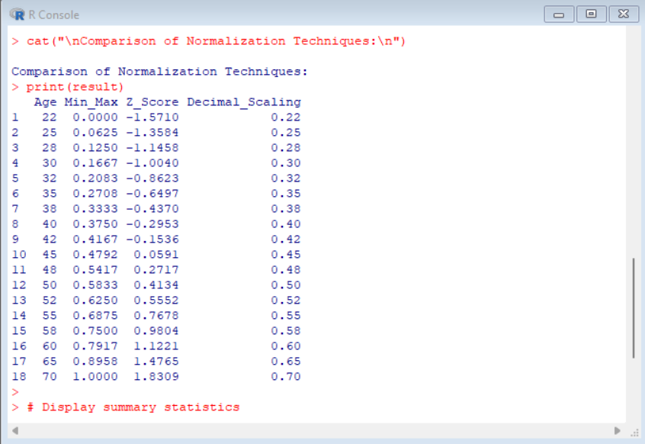

Result:- It is executed successfully.

Experiment -5
Aim:- To demonstrate three normalization techniques on the age data of 18 adults using R programming.
Code:-
age <- c(21, 24, 27, 30, 33, 36, 39, 42, 45,
48, 51, 54, 57, 60, 63, 66, 69, 72)
# Min-Max Normalization
min_max <- (age - min(age)) / (max(age) - min(age))
cat("Min-Max Normalization:\n")
print(round(min_max, 2))
# Z-Score Normalization
z_score <- scale(age)
cat("Z-Score Normalization:\n")
print(round(z_score, 2))
# Decimal Scaling Normalization
decimal <- age / (10^2)
cat("Decimal Scaling Normalization:\n")
print(decimal)
output:-
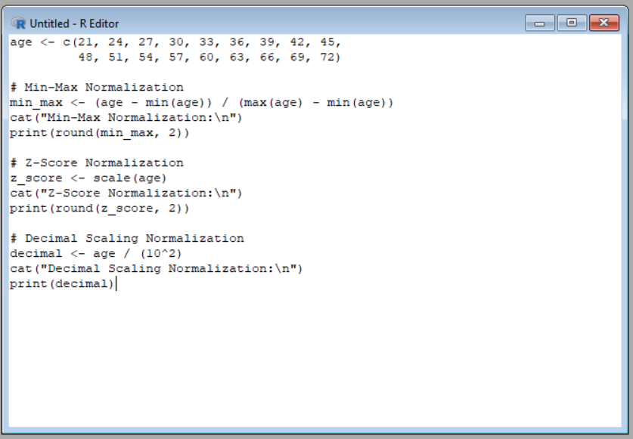

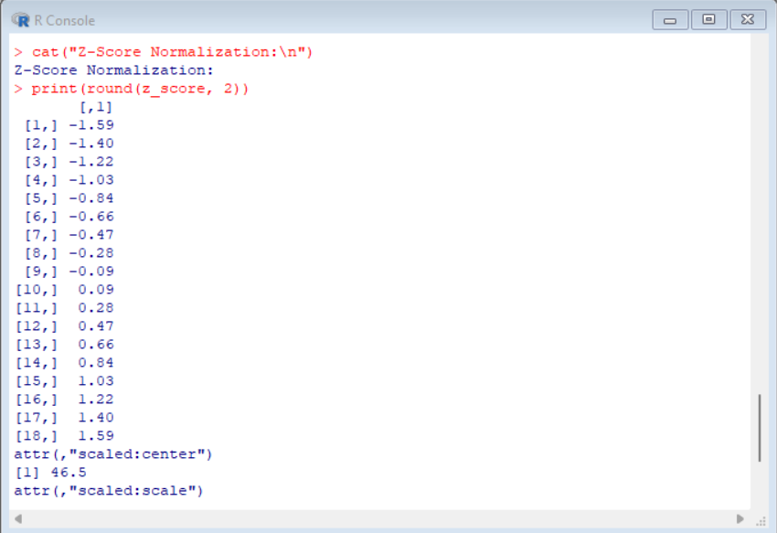

Result:- It is executed successfully.

Experiment-6
Aim:- To calculate the mean, median, and mode of the number of pencils available in different boxes using R programming.
Code:-
pencils <- c(10, 15, 20, 10, 25, 15, 10, 30)
# Mean
print(mean(pencils))
# Median
print(median(pencils))
# Mode
mode_value <- as.numeric(names(which.max(table(pencils))))
print(mode_value)

Output:-
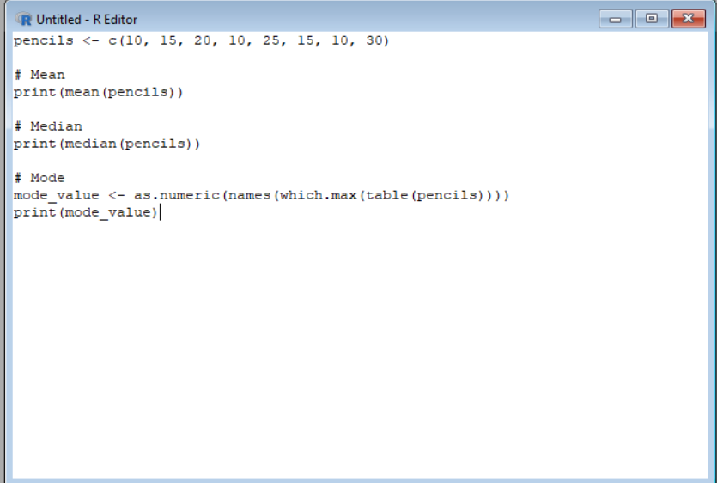
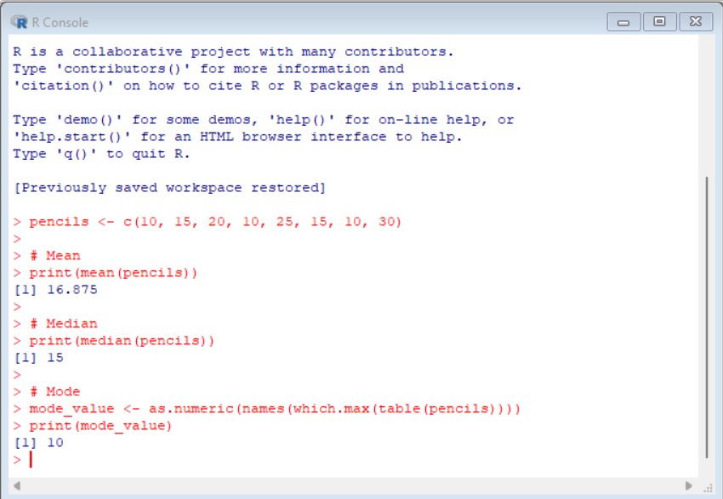
Result:- It is executed successfully.

